## Installation

1. copy the executable into your downloads folder or anywhere you want
2. Run the executable like any program.
   1. Select the installation directory. The default is "C:\Program Files (x86)\panel_builder"
3. Once the program finishes installing navigate to "C:\Program Files (x86)\panel_builder" unless you installed it in a different directory.
   1. Once there right click on "panel_builder.exe" > Properties > check "Run this program as an administrator". This is not a digitally signed application, which is why I think you need to be an administrator to run it.
4. A window should appear with the running application!

## Usage instruction

The main window is shown below. It is the welcome page for functions this tool provides.

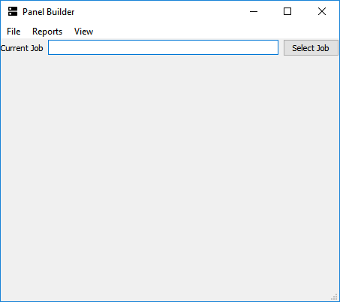

Figure 1 – Main Window

* Select a job (File -> Find Job -> Select the root of a job folder like you typically would in design tool). For example, if a job is located in “D:\Jobs\246728_TXSU_Chemistry_Bldg_Reno\MDT\JobDB.mdt” then choose “D:\Jobs\246728_TXSU_Chemistry_Bldg_Reno” as the job directory. The application looks for “MDT” and “JobDB.mdf” files to open.
* Select Reports -> Open Reports

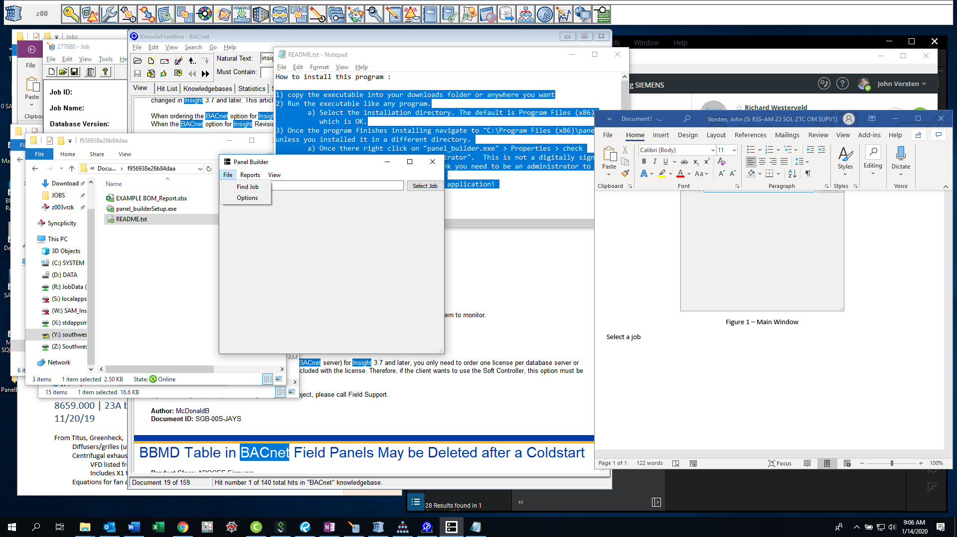

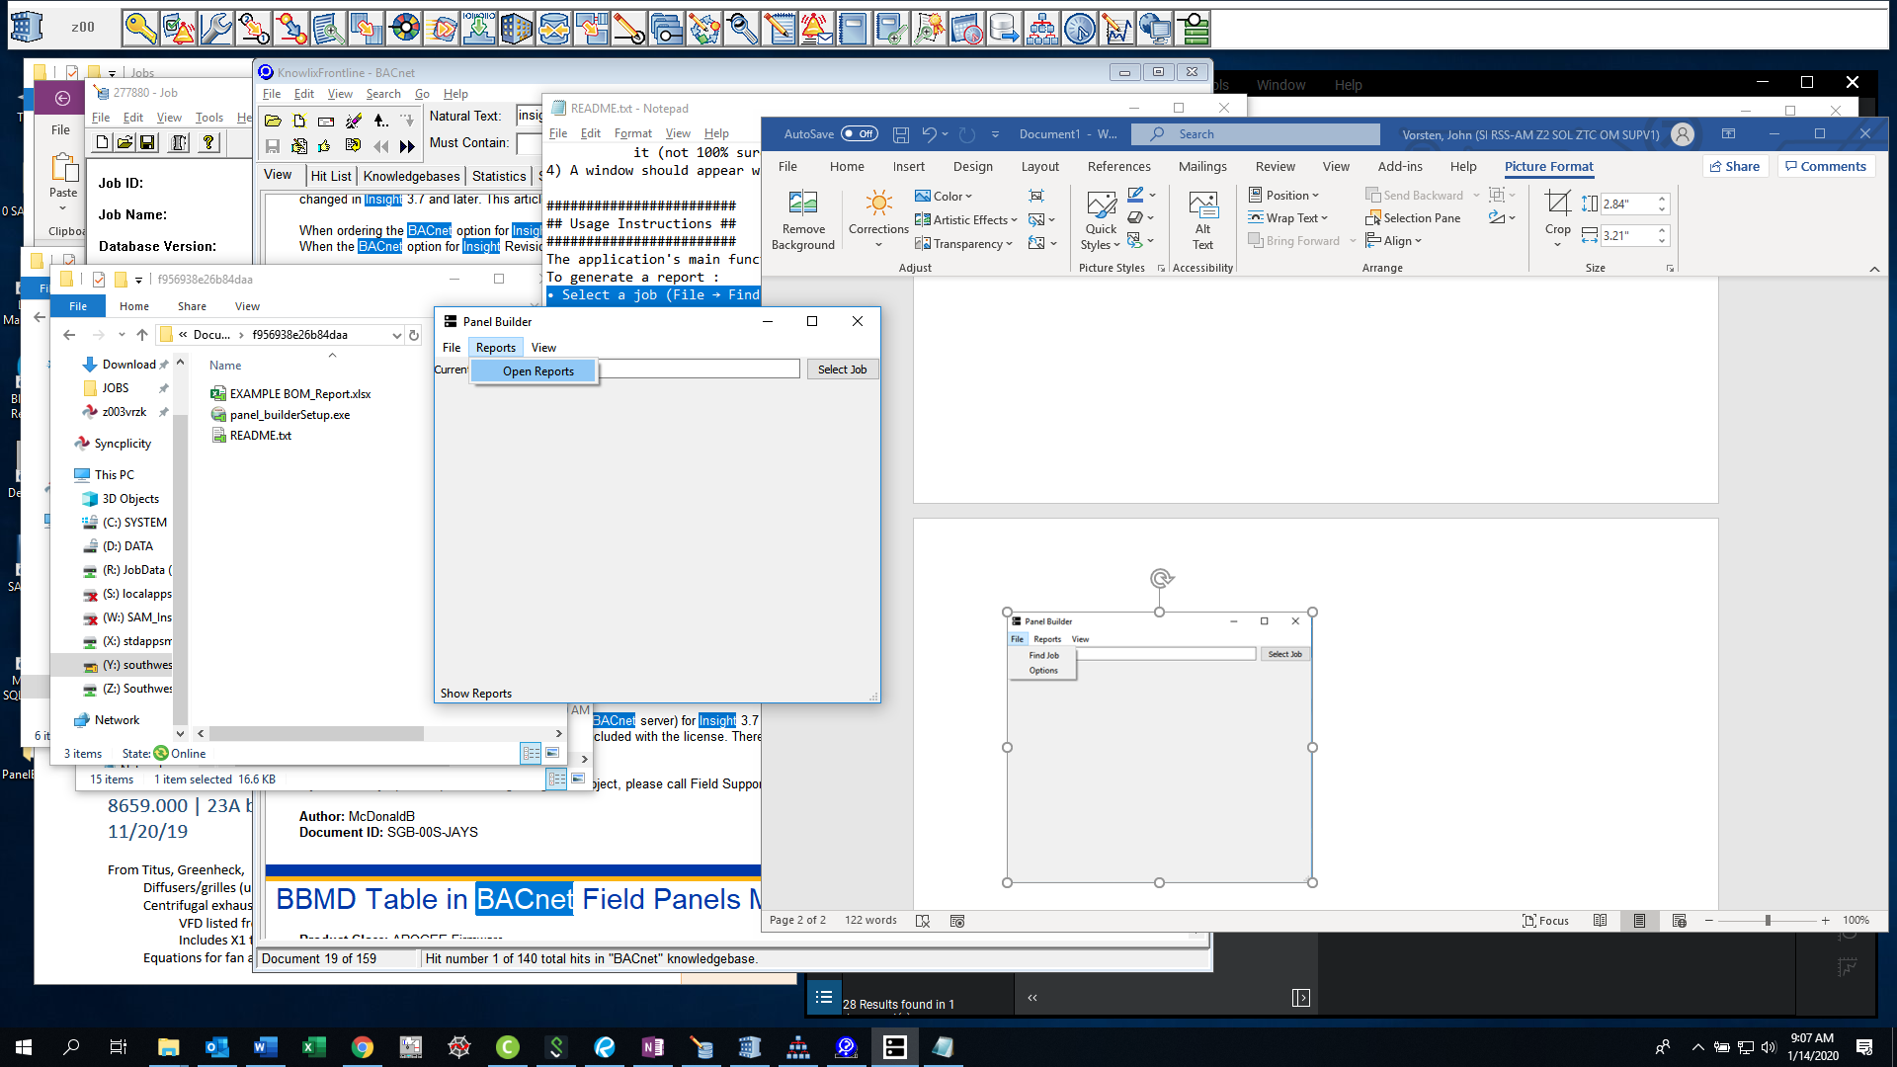

Figure 2, 3 – Selecting a Job & Starting a Report

* Choose which systems you want to select. Choose "All Systems" or manually select systems
* Indicate if you want to include parts marked ETR (+) and included by others (*)
* Check Generate button -> Ok
* Your report should open in Microsoft Excel

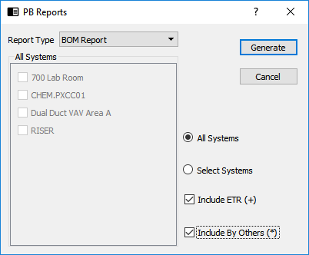

Figure 4 – Report Window

What do the check boxes mean?

‘All Systems’ – All systems in the current job will be reported on. This does NOT include valves or dampers. This could be added later if people want it

‘Select Systems’ – Select individual systems to output. This could be useful for material re-estimates before you’re 100% finished with a job

‘Include ETR (+)’ – Material marked ETR in the job will include a note “+” in the ‘comments’ section of the outputted report. This tool DOES differentiate between parts marked ETR, by others, and standard. For example, if (1) GCA161.1P (ETR) and (1) GCA161.1P (Standard) are in a system then the output will have separate lines for both if ‘Include ETR (+)’ is selected. If the box is not selected, then only (1) GCA161.1P will be output

‘Include By Others (*)’ – Same as ETR

System Select Boxes – Check each box you want to include in the report

‘Generate’ – Start your report (it will open in an excel app window)

## Example Report

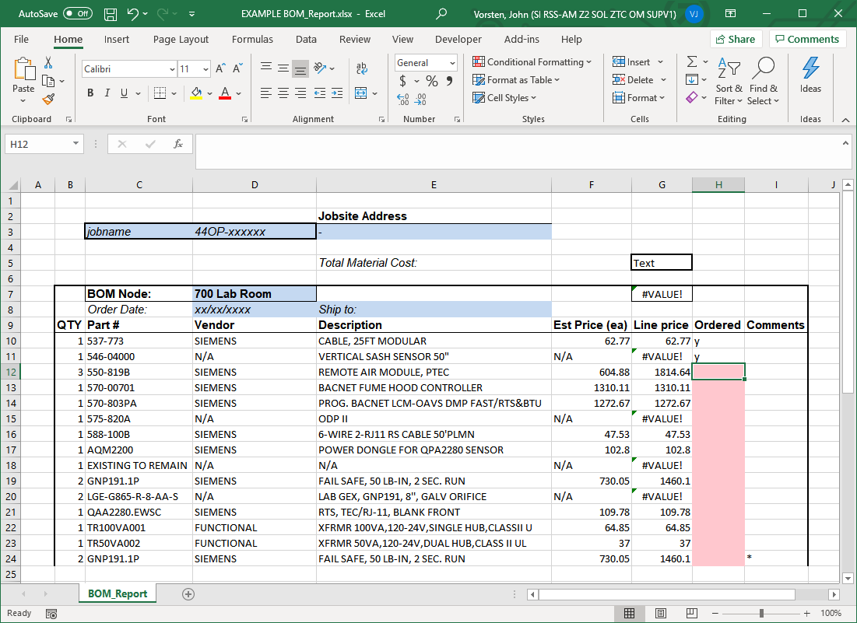

What is included?

Part number and vendor are all taken from the SQL Product Database. This is an intentional design choice, and is made to encourage a central SQL parts database for engineers. In this example some parts are not included in my Product Database, which is why some vendors and prices are missing. In a shared product database the goal is to have accurate prices and vendor numbers that match SAP.

Line price, and system material value are shown using EXCEL formulas (no entry by the user is needed). The #VALUE cell would be updated once all prices are real numbers.

The ‘Ordered’ column contains conditional formatting to check when material is ordered. This is useful for procurement and project managers who want to stagger material for large jobs.

‘BOM Node’ is automatically generate per system, and a separate node is shown per system (see EXAMPLE Bom_Report.xlsx for an example)

Job name, jobsite address, and ship-to information is all entered by the project manager. New parts can be easily inserted from other equipment schedules

## Future work

Add configuration options for SQL server name, Product Database location, designer name (4 hours)

Add option to get values from a networked or local spreadsheet (automatic) until a central product database is active (8 hours)

Add additional columns / adjust the report? (2 hours)

Add a view of all databased parts (see the View - Table View) dialog which is incomplete (2 hours)

Add other reports (8+ hours)

TXIO Counter & panel builder

FLN builder (From commissioning tool)

Automatic points assignment